DIGITAL SYSTEM DESIGN LABORATORY
REPORT LAB 4

BASIC BUILDING BLOCKS OF SINGLE CYCLE MICROPROCESSOR

Name: Bùi Gia Bảo
ID: ITITIU22019

I. LAB OBJECTIVES

This Lab experiments are intended to implement basic building blocks of Single Cycle Microprocessor

II. DESCRIPTION

Single Cycle Microprocessor datapath to be implemented is in figure 2.1.

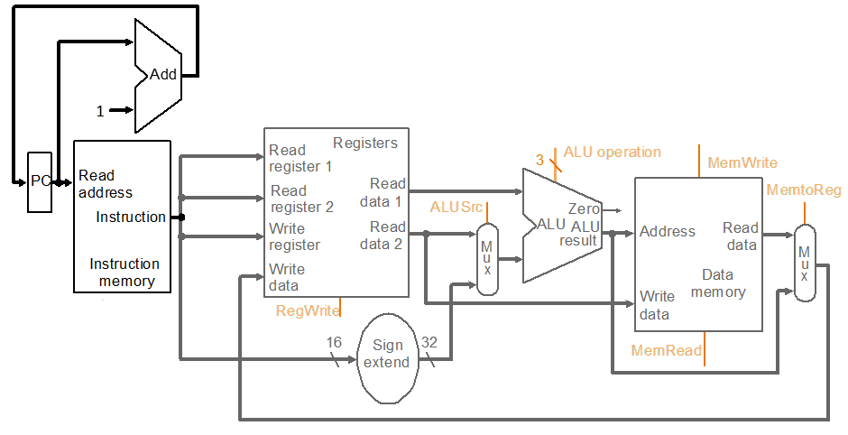

Figure 2.1: Single Cycle Microprocessor DataPath

III. LAB PROCEDURE

III.1 EXPERIMENT NO. 1

III.1.1 AIM: To implement Program Counter

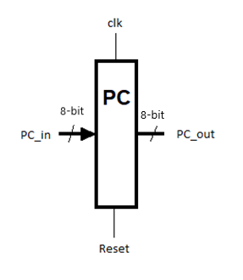
III.1.2 CODE
module Program_Counter (clk, reset, PC_in, PC_out);
input clk, reset;
input [7:0] PC_in;
output [7:0] PC_out;
reg [7:0] PC_out;
always @ (posedge clk or posedge reset)
begin
if(reset==1'b1)
PC_out<=8’b0;
else
PC_out<=PC_in;
end
endmodule

III.1.3 LAB ASSIGNMENT
1. Write testbenches to verify above module and attach waveforms.
2. Write the Top level module to implement this module in FPGA KIT

module lab4_pc(SW,LEDG,LEDR);
input[17:0] SW;
output[7:0] LEDG;
output[17:0] LEDR;
assign LEDR=SW;
Program_Counter (.clk(SW[0]), .reset(SW[1]), .PC_in(SW[9:2]), .PC_out(LEDG[7:0]));
endmodule

module Program_Counter (clk, reset, PC_in, PC_out);
input clk, reset;
input [7:0] PC_in;
output [7:0] PC_out;
reg [7:0] PC_out;
always @ (posedge clk or posedge reset)
begin
if(reset==1'b1)
PC_out<=8'b0;
else
PC_out<=PC_in;
end
endmodule

III.2 EXPERIMENT NO. 2

III.2.1 AIM: To implement 32 bit Adder

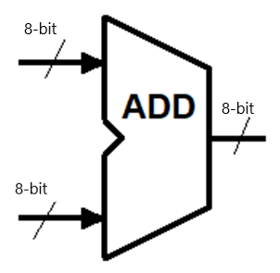

III.2.2 CODE
module Adder32Bit(input1, input2, out);

input [7:0] input1, input2;
output [7:0] out;
reg [7:0]out;
always@( input1 or input2)
begin
out <= input1 + input2;
end
endmodule

III.2.3 LAB ASSIGNMENT
1. Write testbenches to verify above module and attach waveforms.
2. Write the Top level module to implement this module in FPGA KIT

module lab4_adder(SW,LEDG,LEDR,HEX0,HEX1,HEX2,HEX3,HEX4,HEX5);
input[17:0] SW;
output[7:0] LEDG;
output[17:0] LEDR;

output[0:6] HEX0,HEX1,HEX2,HEX3,HEX4,HEX5;
wire [7:0] A,B,SUM;
assign B = SW[15:8];
assign A = SW[7:0];
Adder_8_Bit DUT(.input1(A), .input2(B), .out(SUM));

HEX_7SEG_DECODE H0(.BIN(A[3:0]), .SSD(HEX0));
HEX_7SEG_DECODE H1(.BIN(A[7:4]), .SSD(HEX1));
HEX_7SEG_DECODE H2(.BIN(B[3:0]), .SSD(HEX2));
HEX_7SEG_DECODE H3(.BIN(B[7:4]), .SSD(HEX3));
HEX_7SEG_DECODE H4(.BIN(SUM[3:0]), .SSD(HEX4));
HEX_7SEG_DECODE H5(.BIN(SUM[7:4]), .SSD(HEX5));

endmodule

module Adder_8_Bit(input1, input2, out);

input [7:0] input1, input2;
output [7:0] out;

assign out = input1 + input2;

endmodule

module HEX_7SEG_DECODE(BIN, SSD);
input [15:0] BIN;
output reg [0:6] SSD;

always begin
case(BIN)
0:SSD=7'b0000001;
1:SSD=7'b1001111;
2:SSD=7'b0010010;
3:SSD=7'b0000110;
4:SSD=7'b1001100;
5:SSD=7'b0100100;
6:SSD=7'b0100000;
7:SSD=7'b0001111;
8:SSD=7'b0000000;
9:SSD=7'b0001100;
10:SSD=7'b0001000;
11:SSD=7'b1100000;
12:SSD=7'b0110001;
13:SSD=7'b1000010;
14:SSD=7'b0110000;
15:SSD=7'b0111000;
endcase
end
endmodule

III.3 EXPERIMENT NO. 3

III.3.1 AIM: To implement the datapath for PC = PC + 1

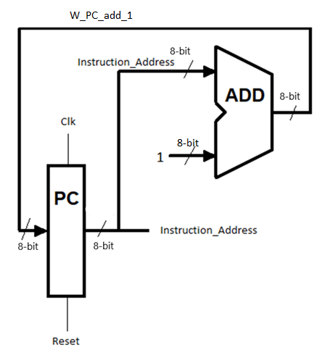
III.3.2 CODE
module lab4_ex3(CLOCK_50,SW,LEDG,LEDR,HEX0,HEX1,HEX2,HEX3,HEX4,HEX5);
input [17:0] SW;
input CLOCK_50;
output [17:0] LEDR;
output [7:0] LEDG;
output [6:0] HEX5, HEX4, HEX3, HEX2, HEX1, HEX0;
wire clk_1Hz;
clock_divider_1Hz div1 (
.clk_in(CLOCK_50),
.reset(SW[1]), // SW[2] = reset
.clk_out(clk_1Hz)
);
PC_add_1 DUT (.clk(clk_1Hz), .reset(SW[1]), .Instruction_Address(LEDG[7:0]));

hex7seg h4(LEDG[3:0], HEX4);
hex7seg h5(LEDG[7:4], HEX5);

endmodule

module PC_add_1 (clk, reset, Instruction_Address);
input clk, reset;
output [7:0] Instruction_Address;

wire [7:0] add_out;

PC pc1(.clk(clk), .reset(reset), .PC_in(add_out), .PC_out(Instruction_Address));
ADD add1(.input1(Instruction_Address), .input2(8'b0000_0001), .out(add_out));
endmodule

module hex7seg(
input wire [3:0] hex,
output reg [6:0] seg
);
always @(*) begin
case (hex)
4'h0: seg = 7'b1000000;
4'h1: seg = 7'b1111001;
4'h2: seg = 7'b0100100;
4'h3: seg = 7'b0110000;
4'h4: seg = 7'b0011001;
4'h5: seg = 7'b0010010;
4'h6: seg = 7'b0000010;
4'h7: seg = 7'b1111000;
4'h8: seg = 7'b0000000;
4'h9: seg = 7'b0010000;
4'hA: seg = 7'b0001000;
4'hB: seg = 7'b0000011;
4'hC: seg = 7'b1000110;
4'hD: seg = 7'b0100001;
4'hE: seg = 7'b0000110;
4'hF: seg = 7'b0001110;
default: seg = 7'b1111111;
endcase
end
endmodule

module ADD(input1, input2, out);

input [7:0] input1, input2;
output [7:0] out;

assign out = input1 + input2;

endmodule

module PC (clk, reset, PC_in, PC_out);
input clk, reset;
input [7:0] PC_in;
output [7:0] PC_out;
reg [7:0] PC_out;
always @ (posedge clk or posedge reset)
begin
if(reset==1'b1)
PC_out<=8'b0;
else
PC_out<=PC_in;
end
endmodule

module clock_divider_1Hz (
input clk_in,
input reset,
output reg clk_out
);
reg [25:0] count;

always @(posedge clk_in or posedge reset) begin
if (reset) begin
count <= 26'd0;
clk_out <= 1'b0;
end else begin
if (count == 26'd24_999_999) begin
clk_out <= ~clk_out;
count <= 26'd0;
end else begin
count <= count + 1;
end
end
end
endmodule

III.4 EXPERIMENT NO. 4

III.4.1 AIM: To implement the Instruction memory

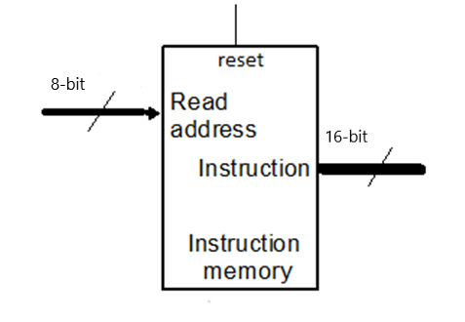
III.4.2 CODE
module Instruction_Memory (read_address, instruction, reset);
input reset;
input [9:0] read_address;
output [15:0] instruction;
reg [15:0] Imemory [1024:0];

Imemory[0] = 32'b00100000000010000000000000100000;
//addi $t0, $zero, 32
Imemory[1] = 32'b00100000000010010000000000110111;
//addi $t1, $zero, 55
Imemory[2] = 32'b00000001000010011000000000100100;
//and $s0, $t0, $t1
Imemory[3] = 32'b00000001000010011000000000100101;
//or $s0, $t0, $t1
Imemory[4] = 32'b10101100000100000000000000000100;
//sw $s0, 4($zero)
Imemory[5] = 32'b10101100000010000000000000001000;
//sw $t0, 8($zero)
Imemory[6] = 32'b00000001000010011000100000100000;
//add $s1, $t0, $t1
Imemory[7] = 32'b00000001000010011001000000100010;
//sub $s2, $t0, $t1
Imemory[8] = 32'b00010010001100100000000000001001;
//beq $s1, $s2, error0
Imemory[9] = 32'b10001100000100010000000000000100;
//lw $s1, 4($zero)
Imemory[10]= 32'b00110010001100100000000001001000;
//andi $s2, $s1, 48
Imemory[11] =32'b00010010001100100000000000001001;
//beq $s1, $s2, error1
Imemory[12] =32'b10001100000100110000000000001000;
//lw $s3, 8($zero)
Imemory[13] =32'b00010010000100110000000000001010;
//beq $s0, $s3, error2
Imemory[14] =32'b00000010010100011010000000101010;
//slt $s4, $s2, $s1 (Last)
Imemory[15] =32'b00010010100000000000000000001111;
//beq $s4, $0, EXIT
Imemory[16] =32'b00000010001000001001000000100000;
//add $s2, $s1, $0
Imemory[17] =32'b00001000000000000000000000001110;
//j Last
Imemory[18] =32'b00100000000010000000000000000000;
//addi $t0, $0, 0(error0)
Imemory[19] =32'b00100000000010010000000000000000;
//addi $t1, $0, 0
Imemory[20] =32'b00001000000000000000000000011111;
//j EXIT
Imemory[21] =32'b00100000000010000000000000000001;
//addi $t0, $0, 1(error1)
Imemory[22] =32'b00100000000010010000000000000001;
//addi $t1, $0, 1
Imemory[23] =32'b00001000000000000000000000011111;
//j EXIT
Imemory[24] =32'b00100000000010000000000000000010;
//addi $t0, $0, 2(error2)
Imemory[25] =32'b00100000000010010000000000000010;
//addi $t1, $0, 2
Imemory[26] =32'b00001000000000000000000000011111;
//j EXIT
Imemory[27] =32'b00100000000010000000000000000011;
//addi $t0, $0, 3(error3)
Imemory[28] =32'b00100000000010010000000000000011;
//addi $t1, $0, 3
Imemory[29] =32'b00001000000000000000000000011111;
//j EXIT
end
endmodule

reset | Read_address | PC_out
1 | 32’b0 | 32'b00100000000010000000000000100000
0 | 32’b0 | 32'b00100000000010000000000000100000
0 | 32’b0000….. 0011 | 32'b00000001000010011000000000100101
0 | 32’b0000 …….0111 | 32'b00000001000010011001000000100010

III.4.3 LAB ASSIGNMENT
1. Write testbenches to verify above module and attach waveforms.
2. Write the Top level module to implement this module in FPGA KIT
module lab4_ex4_v2(SW,LEDG,LEDR,HEX0,HEX1,HEX2,HEX3,HEX4,HEX5);
input[17:0] SW;
output[7:0] LEDG;
output[17:0] LEDR;
output[0:6] HEX0,HEX1,HEX2,HEX3,HEX4,HEX5;
wire[31:0] w_out_instruction;

assign LEDR[15:0] = SW[17] ? w_out_instruction[31:16] : w_out_instruction[15:0];

Instruction_Memory (.read_address(SW[5:0]), .instruction(w_out_instruction));

endmodule

module Instruction_Memory (read_address, instruction);
input [7:0] read_address;
output [31:0] instruction;
reg [31:0] Imemory [63:0];
assign instruction=Imemory[read_address];
initial begin
Imemory[0] = 32'b00100000000010000000000000100000;
//addi $t0, $zero, 32
Imemory[1] = 32'b00100000000010010000000000110111;
//addi $t1, $zero, 55
Imemory[2] = 32'b00000001000010011000000000100100;
//and $s0, $t0, $t1
Imemory[3] = 32'b00000001000010011000000000100101;
//or $s0, $t0, $t1
Imemory[4] = 32'b10101100000100000000000000000100;
//sw $s0, 4($zero)
Imemory[5] = 32'b10101100000010000000000000001000;
//sw $t0, 8($zero)
Imemory[6] = 32'b00000001000010011000100000100000;
//add $s1, $t0, $t1
Imemory[7] = 32'b00000001000010011001000000100010;
//sub $s2, $t0, $t1
Imemory[8] = 32'b00010010001100100000000000001001;
//beq $s1, $s2, error0
Imemory[9] = 32'b10001100000100010000000000000100;
//lw $s1, 4($zero)
Imemory[10]= 32'b00110010001100100000000001001000;
//andi $s2, $s1, 48
Imemory[11] =32'b00010010001100100000000000001001;
//beq $s1, $s2, error1
Imemory[12] =32'b10001100000100110000000000001000;
//lw $s3, 8($zero)
Imemory[13] =32'b00010010000100110000000000001010;
//beq $s0, $s3, error2
Imemory[14] =32'b00000010010100011010000000101010;
//slt $s4, $s2, $s1 (Last)
Imemory[15] =32'b00010010100000000000000000001111;
//beq $s4, $0, EXIT
Imemory[16] =32'b00000010001000001001000000100000;
//add $s2, $s1, $0
Imemory[17] =32'b00001000000000000000000000001110;
//j Last
Imemory[18] =32'b00100000000010000000000000000000;
//addi $t0, $0, 0(error0)
Imemory[19] =32'b00100000000010010000000000000000;
//addi $t1, $0, 0
Imemory[20] =32'b00001000000000000000000000011111;
//j EXIT
Imemory[21] =32'b00100000000010000000000000000001;
//addi $t0, $0, 1(error1)
Imemory[22] =32'b00100000000010010000000000000001;
//addi $t1, $0, 1
Imemory[23] =32'b00001000000000000000000000011111;
//j EXIT
Imemory[24] =32'b00100000000010000000000000000010;
//addi $t0, $0, 2(error2)
Imemory[25] =32'b00100000000010010000000000000010;
//addi $t1, $0, 2
Imemory[26] =32'b00001000000000000000000000011111;
//j EXIT
Imemory[27] =32'b00100000000010000000000000000011;
//addi $t0, $0, 3(error3)
Imemory[28] =32'b00100000000010010000000000000011;
//addi $t1, $0, 3
Imemory[29] =32'b00001000000000000000000000011111;
//j EXIT
end
endmodule

III.5 EXPERIMENT NO. 5

III.5.1 AIM: To implement the Instruction memory datapath

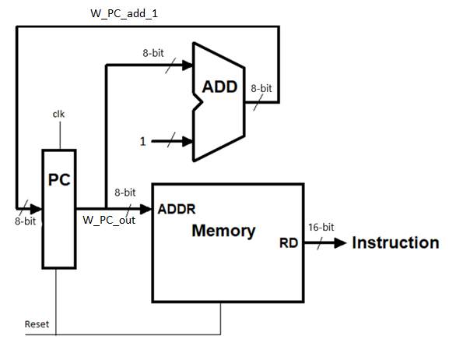

III.5.2 CODE
module Instruction_Datapath (clk, reset, Instruction);
input clk, reset;
output [15:0] Instruction;

endmodule

III.5.3 LAB ASSIGNMENT
1. Write testbenches to verify above module and attach waveforms.
2. Write the Top level module to implement this module in FPGA KIT
module lab4_ex5(CLOCK_50,SW,LEDG,LEDR,HEX0,HEX1,HEX2,HEX3,HEX4,HEX5,HEX6,HEX7);
input [17:0] SW;
output [17:0] LEDR;
output [7:0] LEDG;
output [7:0] HEX7,HEX6,HEX5, HEX4, HEX3, HEX2, HEX1, HEX0;
input CLOCK_50;
wire clk_1Hz;
wire [31:0] OUT;
clock_divider_1Hz div1 (
.clk_in(CLOCK_50),
.reset(SW[0]), // SW[2] = reset
.clk_out(clk_1Hz)
);

Instruction_Datapath DUT (.clk(clk_1Hz), .reset(SW[0]),.instruction_address(LEDG), .Instruction(OUT));

wire SEL;
assign SEL = SW[17];
assign LEDR = SEL ? OUT[15:0] : OUT[31:16];

hex7seg h0(OUT[3:0], HEX0);
hex7seg h1(OUT[7:4], HEX1);
hex7seg h2(OUT[11:8], HEX2);
hex7seg h3(OUT[15:12], HEX3);
hex7seg h4(OUT[19:16], HEX4);
hex7seg h5(OUT[23:20], HEX5);
hex7seg h6(OUT[27:24], HEX6);
hex7seg h7(OUT[31:28], HEX7);

endmodule

module Instruction_Datapath (clk, reset, instruction_address, Instruction);
input clk, reset;
output [31:0] Instruction;
output [7:0] instruction_address;

PC_ADD DUT1(.clk(clk), .reset(reset), .Instruction_Address(instruction_address));
MEMORY DUT2(.read_address(instruction_address), .instruction(Instruction), .reset(reset));
endmodule

module hex7seg(
input wire [3:0] hex,
output reg [7:0] seg
);
always @(*) begin
case (hex)
4'h0: seg = 8'b11000000;
4'h1: seg = 8'b11111001;
4'h2: seg = 8'b10100100;
4'h3: seg = 8'b10110000;
4'h4: seg = 8'b10011001;
4'h5: seg = 8'b10010010;
4'h6: seg = 8'b10000010;
4'h7: seg = 8'b11111000;
4'h8: seg = 8'b10000000;
4'h9: seg = 8'b10010000;
4'hA: seg = 8'b10001000;
4'hB: seg = 8'b10000011;
4'hC: seg = 8'b11000110;
4'hD: seg = 8'b10100001;
4'hE: seg = 8'b10000110;
4'hF: seg = 8'b10001110;
default: seg = 8'b11111111;
endcase
end
endmodule

module PC_ADD (clk, reset, Instruction_Address);
input clk, reset;
output [7:0] Instruction_Address;

wire [7:0] add_out;

PC pc1(.clk(clk), .reset(reset), .PC_in(add_out), .PC_out(Instruction_Address));
ADD add1(.input1(Instruction_Address), .input2(8'b0000_0001), .out(add_out));
endmodule

module PC (clk, reset, PC_in, PC_out);
input clk, reset;
input [7:0] PC_in;
output [7:0] PC_out;
reg [7:0] PC_out;
always @ (posedge clk or posedge reset)
begin
if(reset==1'b1)
PC_out<=8'b0;
else
PC_out<=PC_in;
end
endmodule

module ADD(input1, input2, out);

input [7:0] input1, input2;
output [7:0] out;

assign out = input1 + input2;

endmodule

module MEMORY (read_address, instruction, reset);
input reset;
input [7:0] read_address;
output reg [31:0] instruction;
reg [31:0] Imemory [1024:0];

always @(*) begin
Imemory[0] = 32'b00100000000010000000000000100000;
//addi $t0, $zero, 32
Imemory[1] = 32'b00100000000010010000000000110111;
//addi $t1, $zero, 55
Imemory[2] = 32'b00000001000010011000000000100100;
//and $s0, $t0, $t1
Imemory[3] = 32'b00000001000010011000000000100101;
//or $s0, $t0, $t1
Imemory[4] = 32'b10101100000100000000000000000100;
//sw $s0, 4($zero)
Imemory[5] = 32'b10101100000010000000000000001000;
//sw $t0, 8($zero)
Imemory[6] = 32'b00000001000010011000100000100000;
//add $s1, $t0, $t1
Imemory[7] = 32'b00000001000010011001000000100010;
//sub $s2, $t0, $t1
Imemory[8] = 32'b00010010001100100000000000001001;
//beq $s1, $s2, error0
Imemory[9] = 32'b10001100000100010000000000000100;
//lw $s1, 4($zero)
Imemory[10]= 32'b00110010001100100000000001001000;
//andi $s2, $s1, 48
Imemory[11] =32'b00010010001100100000000000001001;
//beq $s1, $s2, error1
Imemory[12] =32'b10001100000100110000000000001000;
//lw $s3, 8($zero)
Imemory[13] =32'b00010010000100110000000000001010;
//beq $s0, $s3, error2
Imemory[14] =32'b00000010010100011010000000101010;
//slt $s4, $s2, $s1 (Last)
Imemory[15] =32'b00010010100000000000000000001111;
//beq $s4, $0, EXIT
Imemory[16] =32'b00000010001000001001000000100000;
//add $s2, $s1, $0
Imemory[17] =32'b00001000000000000000000000001110;
//j Last
Imemory[18] =32'b00100000000010000000000000000000;
//addi $t0, $0, 0(error0)
Imemory[19] =32'b00100000000010010000000000000000;
//addi $t1, $0, 0
Imemory[20] =32'b00001000000000000000000000011111;
//j EXIT
Imemory[21] =32'b00100000000010000000000000000001;
//addi $t0, $0, 1(error1)
Imemory[22] =32'b00100000000010010000000000000001;
//addi $t1, $0, 1
Imemory[23] =32'b00001000000000000000000000011111;
//j EXIT
Imemory[24] =32'b00100000000010000000000000000010;
//addi $t0, $0, 2(error2)
Imemory[25] =32'b00100000000010010000000000000010;
//addi $t1, $0, 2
Imemory[26] =32'b00001000000000000000000000011111;
//j EXIT
Imemory[27] =32'b00100000000010000000000000000011;
//addi $t0, $0, 3(error3)
Imemory[28] =32'b00100000000010010000000000000011;
//addi $t1, $0, 3
Imemory[29] =32'b00001000000000000000000000011111;
//j EXIT
end

always @(*) begin
if(reset)
instruction = 31'b0;
else
instruction = Imemory[read_address];
end
endmodule

module clock_divider_1Hz (
input clk_in,
input reset,
output reg clk_out
);
reg [25:0] count;

always @(posedge clk_in or posedge reset) begin
if (reset) begin
count <= 26'd0;
clk_out <= 1'b0;
end else begin
if (count == 26'd24_999_999) begin
clk_out <= ~clk_out;
count <= 26'd0;
end else begin
count <= count + 1;
end
end
end
endmodule

III.6 EXPERIMENT NO. 6

III.6.1 AIM: To implement the Register File

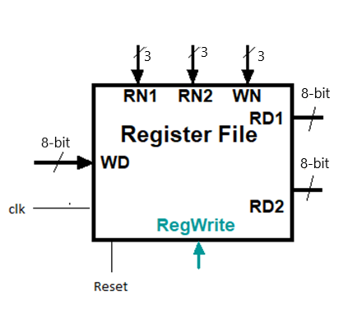

III.6.2 CODE
module Register_File (read_addr_1, read_addr_2, write_addr, read_data_1, read_data_2, write_data, RegWrite, clk, reset);
input [2:0] read_addr_1, read_addr_2, write_addr;
input [7:0] write_data;
input clk, reset, RegWrite;
output [7:0] read_data_1, read_data_2;

reg [7:0] Regfile [7:0];
integer k;

assign read_data_1 = Regfile[read_addr_1];

assign read_data_2 = Regfile[read_addr_2];

always @(posedge clk or posedge reset)
begin
if (reset==1'b1)
begin
for (k=0; k<8; k=k+1)
begin
Regfile[k] = 8'b0;
end
end

else if (RegWrite == 1'b1) Regfile[write_addr] = write_data;
end

endmodule

reset | clk | read_addr_1 | read_data_1 | read_addr_2 | read_data_2 | RegWrite | write_addr | write_data
1 | x | x | 32’b0 | x | 32’b0 | x | x | x
0 | ↑ | 32’d3 | 32’b0 | 32’d4 | 32’b0 | 1 | 32’b001 | 32’b0111
0 | ↑ | 32’d3 | 32’b0 | 32’d4 | 32’b0 | 1 | 32’b010 | 32’b1000
0 | ↑ | 32’d3 | 32’b0 | 32’d4 | 32’b0 | 1 | 32’b011 | 32’b1001
0 | ↑ | 32’d3 | 32’b0 | 32’d4 | 32’b0 | 1 | 32’b100 | 32’b1010
0 | ↑ | 32’d3 | 32’b0 | 32’b00 | 32’b0 | 1 | 32’b101 | 32’b1011
0 | ↑ | 32’b001 | 32’b0111 | 32’b101 | 32’b1011 | 0 | x | x
0 | ↑ | 32’b011 | 32’b1001 | 32’b100 | 32’b1010 | 0 | x | x
0 | ↑ | 32’b101 | 32’b1011 | 32’b101 | 32’b1011 | 0 | x | x
0 | ↑ | 32’b100 | 32’b1010 | 32’b100 | 32’b1010 | 0 | x | x

III.6.3 LAB ASSIGNMENT
1. Write testbenches to verify above module and attach waveforms.
2. Write the Top level module to implement this module in FPGA KIT
module lab4_ex6_v2(KEY,SW,LEDG,LEDR,HEX0,HEX1,HEX2,HEX3,HEX4,HEX5);
input[3:0] KEY;
input[17:0] SW;
output[7:0] LEDG;
output[17:0] LEDR;
output[0:6] HEX0,HEX1,HEX2,HEX3,HEX4,HEX5;
wire [7:0] W_LED_HEX_1_0,W_LED_HEX_3_2;
assign LEDR = SW;
Register_File DUT( .read_addr_1(SW[17:15]),
.read_addr_2(SW[14:12]),
.write_addr(SW[11:9]),
.read_data_1(W_LED_HEX_1_0),
.read_data_2(W_LED_HEX_3_2),
.write_data(SW[8:1]),
.RegWrite(SW[0]),
.clk(KEY[0]),
.reset(KEY[1]));

HEX_7SEG_DECODE H0(.BIN(W_LED_HEX_1_0[3:0]), .SSD(HEX0));
HEX_7SEG_DECODE H1(.BIN(W_LED_HEX_1_0[7:4]), .SSD(HEX1));
HEX_7SEG_DECODE H2(.BIN(W_LED_HEX_3_2[3:0]), .SSD(HEX2));
HEX_7SEG_DECODE H3(.BIN(W_LED_HEX_3_2[7:4]), .SSD(HEX3));

endmodule

module HEX_7SEG_DECODE(BIN, SSD);
input [3:0] BIN;
output reg [0:6] SSD;
always begin
case(BIN)
0:SSD=7'b0000001;
1:SSD=7'b1001111;
2:SSD=7'b0010010;
3:SSD=7'b0000110;
4:SSD=7'b1001100;
5:SSD=7'b0100100;
6:SSD=7'b0100000;
7:SSD=7'b0001111;
8:SSD=7'b0000000;
9:SSD=7'b0001100;
10:SSD=7'b0001000;
11:SSD=7'b1100000;
12:SSD=7'b0110001;
13:SSD=7'b1000010;
14:SSD=7'b0110000;
15:SSD=7'b0111000;
endcase
end
endmodule

module Register_File (read_addr_1, read_addr_2, write_addr, read_data_1, read_data_2, write_data, RegWrite, clk, reset);
input [2:0] read_addr_1, read_addr_2, write_addr;
input [7:0] write_data;
input clk, reset, RegWrite;
output [7:0] read_data_1, read_data_2;

reg [7:0] Regfile [7:0];
integer k;

assign read_data_1 = Regfile[read_addr_1];

assign read_data_2 = Regfile[read_addr_2];

always @(posedge clk or negedge reset)
begin
if (reset==1'b0)
begin
for (k=0; k<8; k=k+1)
begin
Regfile[k] = 8'b0;
end
end

else if (RegWrite == 1'b1) Regfile[write_addr] = write_data;
end

endmodule

III.7 EXPERIMENT NO. 7

III.7.1 AIM: To implement the ALU

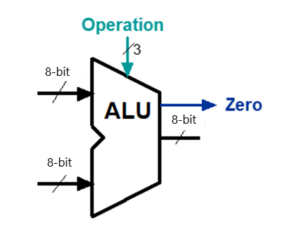
III.7.2 CODE
module alu(
input [2:0] alufn,
input [7:0] ra,
input [7:0] rb_or_imm,
output reg [7:0] aluout,
output reg zero);

parameter ALU_OP_ADD = 3'b000,
ALU_OP_SUB = 3'b001,
ALU_OP_AND = 3'b010,
ALU_OP_OR = 3'b011,
ALU_OP_NOT_A = 3'b100,
ALU_OP_LW = 3'b101,
ALU_OP_SW = 3'b110,
ALU_OP_BEQ = 3'b111;
always @(*)
begin
case(alufn)
ALU_OP_ADD : aluout = ra + rb_or_imm;
ALU_OP_SUB : aluout = ra - rb_or_imm;
ALU_OP_AND : aluout = ra & rb_or_imm;
ALU_OP_OR : aluout = ra | rb_or_imm;
ALU_OP_NOT_A : aluout = ~ ra;
ALU_OP_LW : aluout = ra + rb_or_imm;
ALU_OP_SW : aluout = ra + rb_or_imm;
ALU_OP_BEQ : begin
zero = (ra==rb_or_imm)?1'b1:1'b0;
aluout = ra - rb_or_imm;
end
endcase
end

endmodule

alufn | ra | rb_or_imm | aluout | zero
3'b000 | 32’d8 | 32’d2 | 32’d10 | 0
3'b001 | 32’d8 | 32’d2 | 32’d6 | 0
3'b010 | 32’b1000 | 32’b0010 | 32’b0000 | 0
3'b011 | 32’b1000 | 32’b0010 | 32’b1010 | 0
3'b100 | 32’b1000 | 32’d2 | 32’b0111 | 0
3'b101 | 32’d8 | 32’d2 | 32’d10 | 0
3'b110 | 32’d8 | 32’d2 | 32’d10 | 0
3'b111 | 32’d8 | 32’d2 | 32’d6 | 0
3'b111 | 32’d8 | 32’d8 | 32’d0 | 1

III.7.3 LAB ASSIGNMENT
1. Write testbenches to verify above module and attach waveforms.
2. Write the Top level module to implement this module in FPGA KIT

module lab4_ex7(LEDR, LEDG, SW);
input [17:0] SW;
output [17:0] LEDR;
output [7:0] LEDG;
assign LEDR =SW;

alu(.alufn(SW[17:15]),
.ra(SW[6:0]),
.rb_or_imm(SW[14:7]),
.aluout(LEDG[6:0]),
.zero(LEDG[7]));

endmodule

III.8 EXPERIMENT NO. 8

III.8.1 AIM: To implement the 32 bit RAM

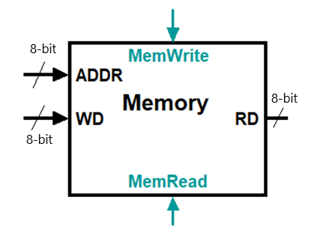
III.8.2 CODE
module Data_Memory (addr, write_data, read_data, clk, reset, MemRead, MemWrite);
input [7:0] addr;
input [7:0] write_data;
output [7:0] read_data;
input clk, reset, MemRead, MemWrite;
reg [7:0] DMemory [7:0];
integer k;
assign read_data = (MemRead) ? DMemory[addr] : 8'bx;

always @(posedge clk or posedge reset)
begin
if (reset == 1'b1)
begin
for (k=0; k<8; k=k+1)
begin
DMemory[k] = 8'b0;
end
end
else
if (MemWrite) DMemory[addr] = write_data;
end
endmodule

III.8.3 LAB ASSIGNMENT
1. Write testbenches to verify above module and attach waveforms.
2. Write the Top level module to implement this module in FPGA KIT

module lab4_ex8(SW,LEDG,LEDR);
input [17:0] SW;
output [17:0] LEDR;
output [7:0] LEDG;
assign LEDR = SW;

Data_Memory ( .addr(SW[6:0]),
.write_data(SW[13:7]),
.read_data(LEDG[6:0]),
.clk(SW[17]),
.reset(SW[16]),
.MemRead(SW[15]),
.MemWrite(SW[14]));

Endmodule

III.9 EXPERIMENT NO. 9

III.9.1 AIM: To implement Multiplexer

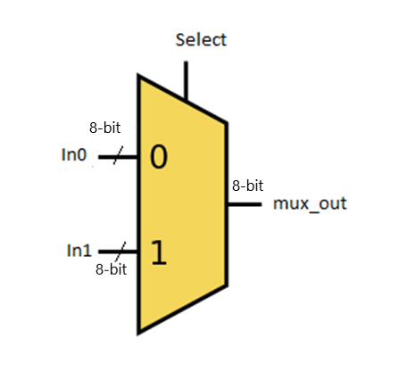
III.9.2 CODE
module Mux_N_bit (in0, in1, mux_out, select);
parameter N = 32;
input [N-1:0] in0, in1;
output [N-1:0] mux_out;
input control;
assign mux_out = select? in1: in0 ;
endmodule

III.9.3 LAB ASSIGNMENT
1. Write testbenches to verify above module and attach waveforms.
2. Write the Top level module to implement this module in FPGA KIT

module lab4_ex9(SW, LEDR, LEDG);
input[17:0] SW;
output[7:0] LEDG;
output[17:0] LEDR;

Mux_N_bit (.in0(SW[7:0]), .in1(SW[15:8]), .mux_out(LEDG[7:0]), .select(SW[16]));

endmodule

module Mux_N_bit (in0, in1, mux_out, select);
parameter N = 8;
input select;
input [N-1:0] in0, in1;
output [N-1:0] mux_out;
assign mux_out = select? in1: in0 ;
endmodule

III.10 EXPERIMENT NO. 10

III.10.1 AIM: To implement Sign_Extension

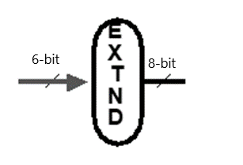
III.10.2 CODE
module Sign_Extension (sign_in, sign_out);
input [15:0] sign_in;
output [31:0] sign_out;
assign sign_out[15:0]=sign_in[15:0];
assign sign_out[31:16]=sign_in[15]?{16{1'b1}}:16'b0;
endmodule

III.10.3 LAB ASSIGNMENT
1. Write testbenches to verify above module and attach waveforms.
2. Write the Top level module to implement this module in FPGA KIT

module lab4_ex10(SW, LEDR,LEDG);
input[17:0] SW;
output[7:0] LEDG;
output[17:0] LEDR;

Sign_Extension (.sign_in(SW[4:0]), .sign_out(LEDG[7:0]));
endmodule

module Sign_Extension (sign_in, sign_out);
input [4:0] sign_in;
output [7:0] sign_out;
assign sign_out[4:0]=sign_in[4:0];
assign sign_out[7:5]=sign_in[4]?{3{1'b1}}:3'b0;
endmodule

